1. Application context in beans java class @Component is there

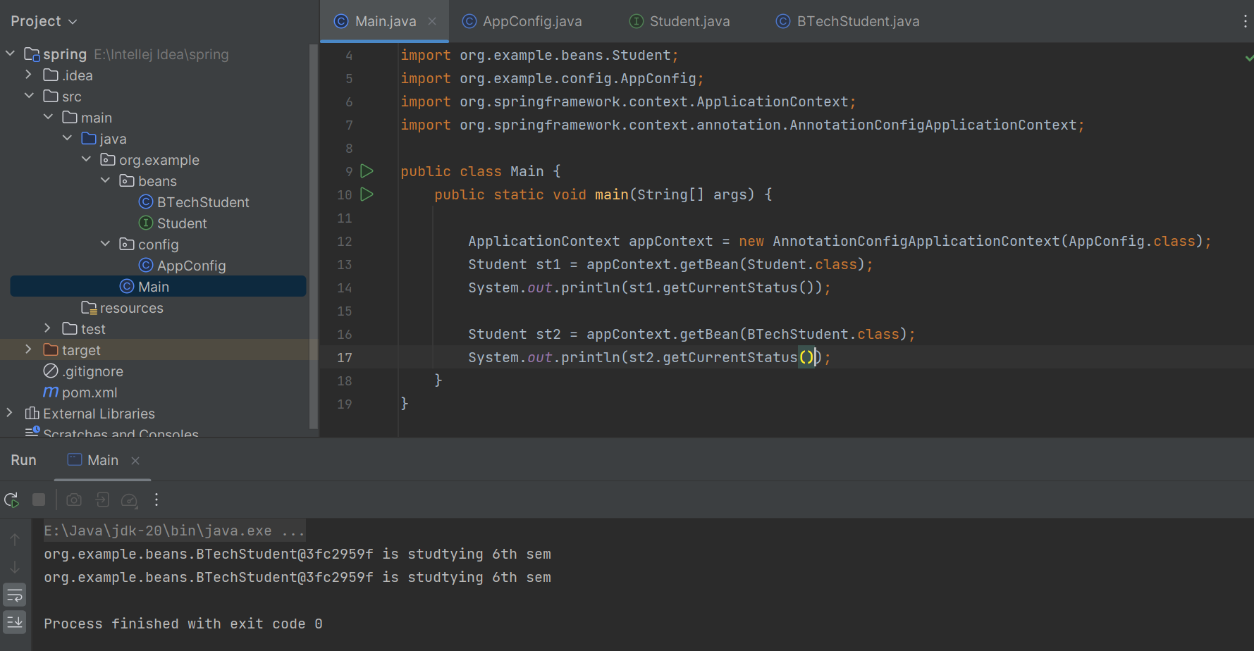

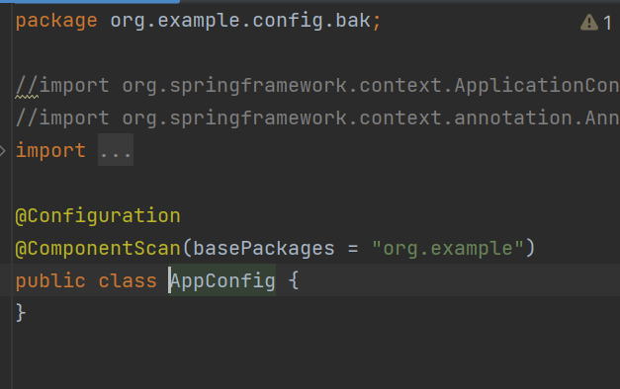

2. Traditional way xml: in bean Java class @Component is not there

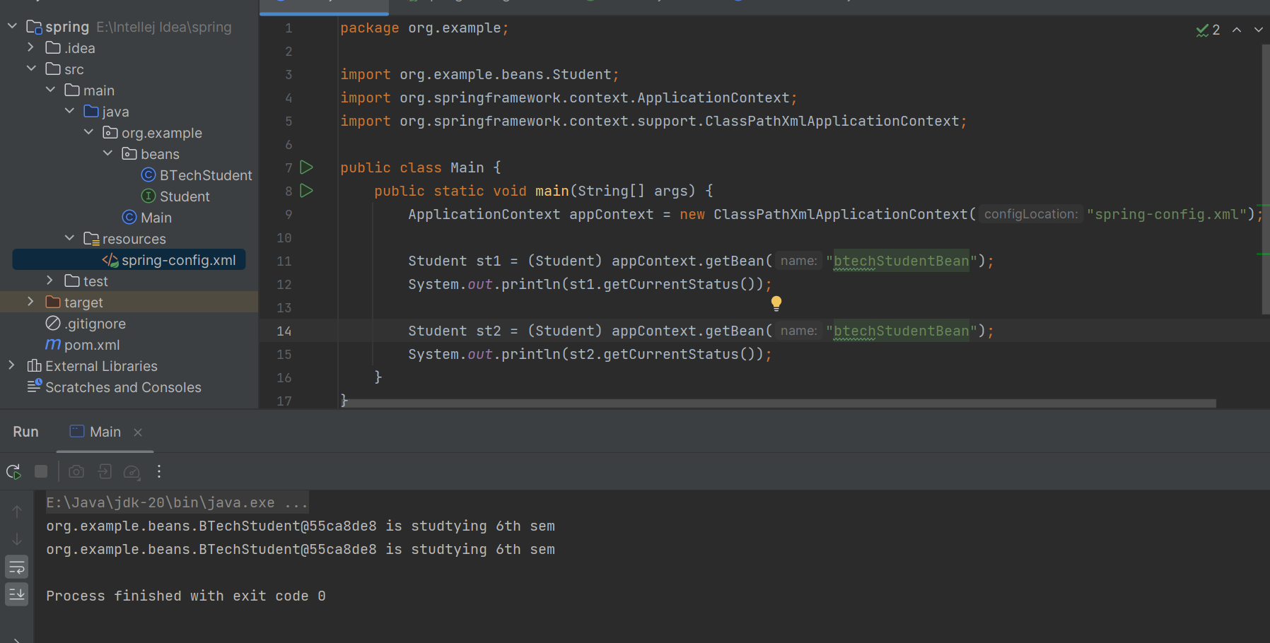

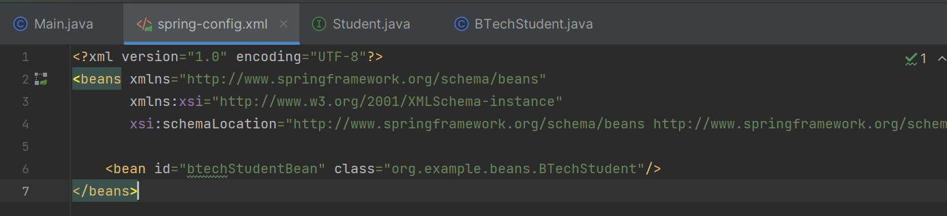

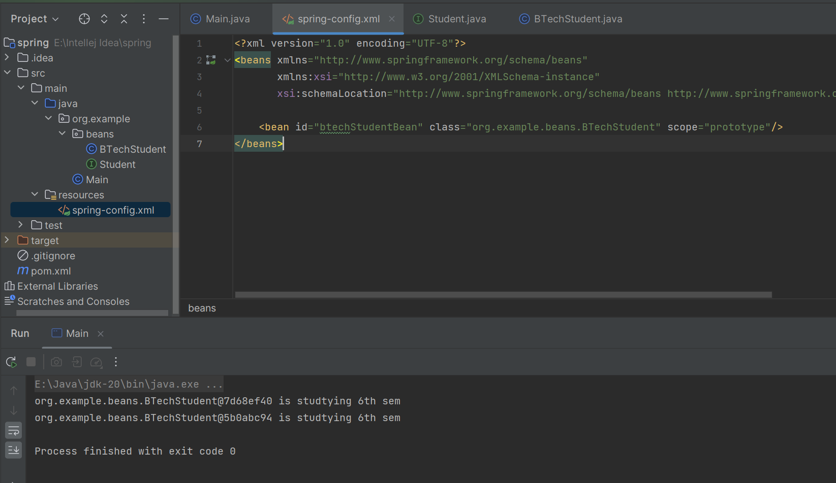

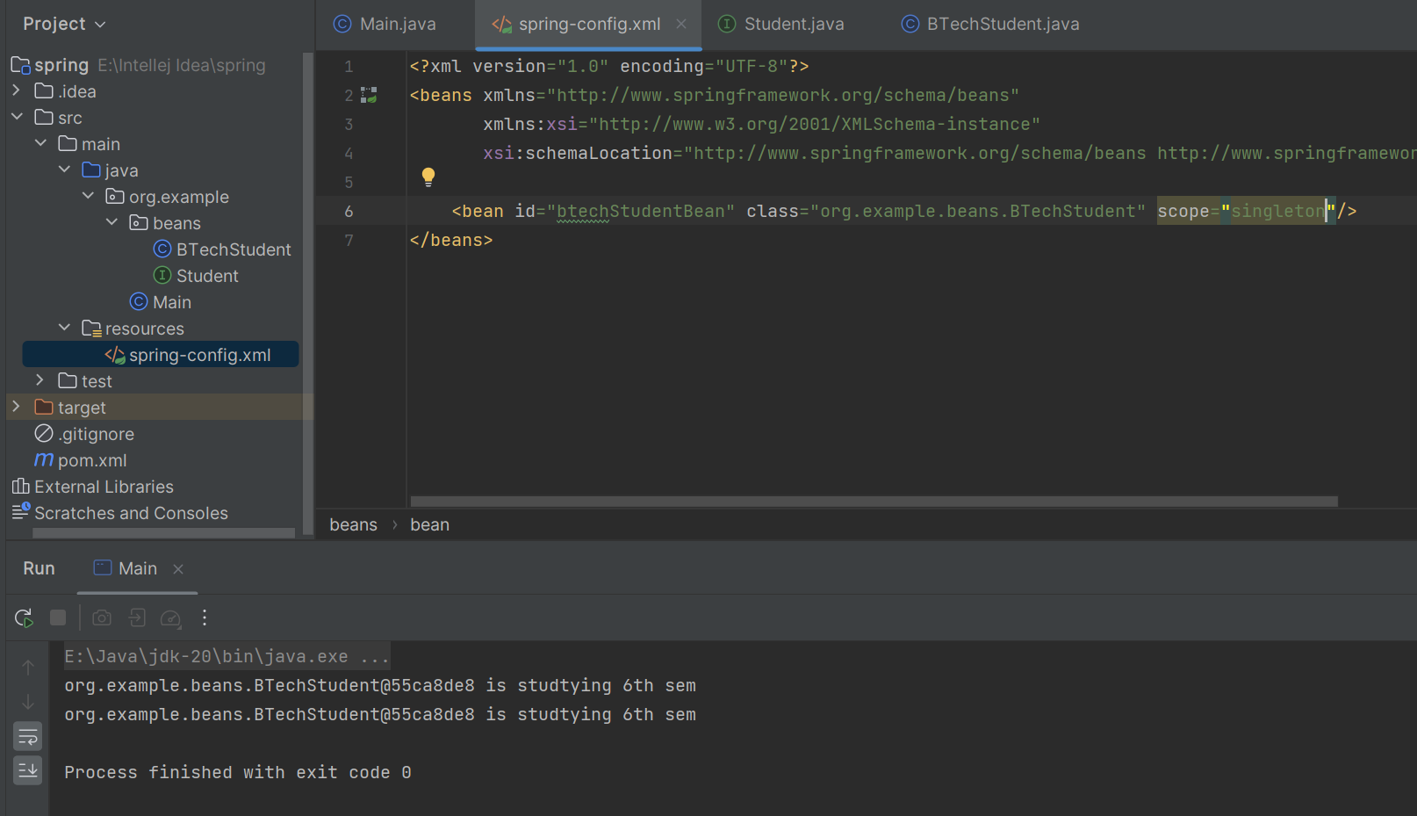

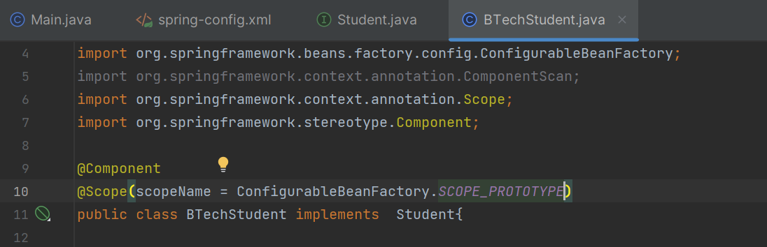

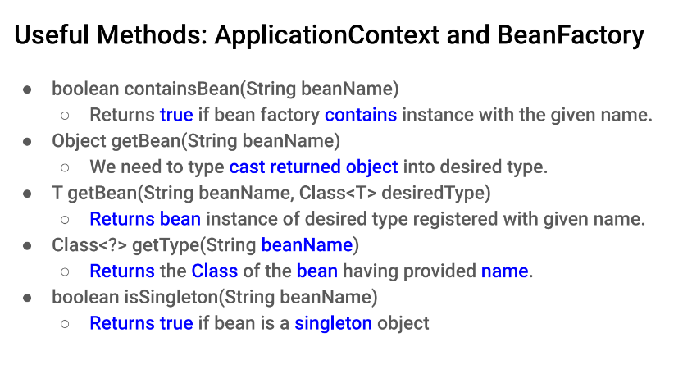

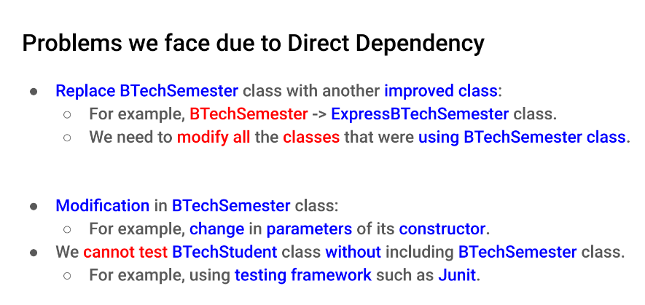

3. creating object using autowiring in constructor

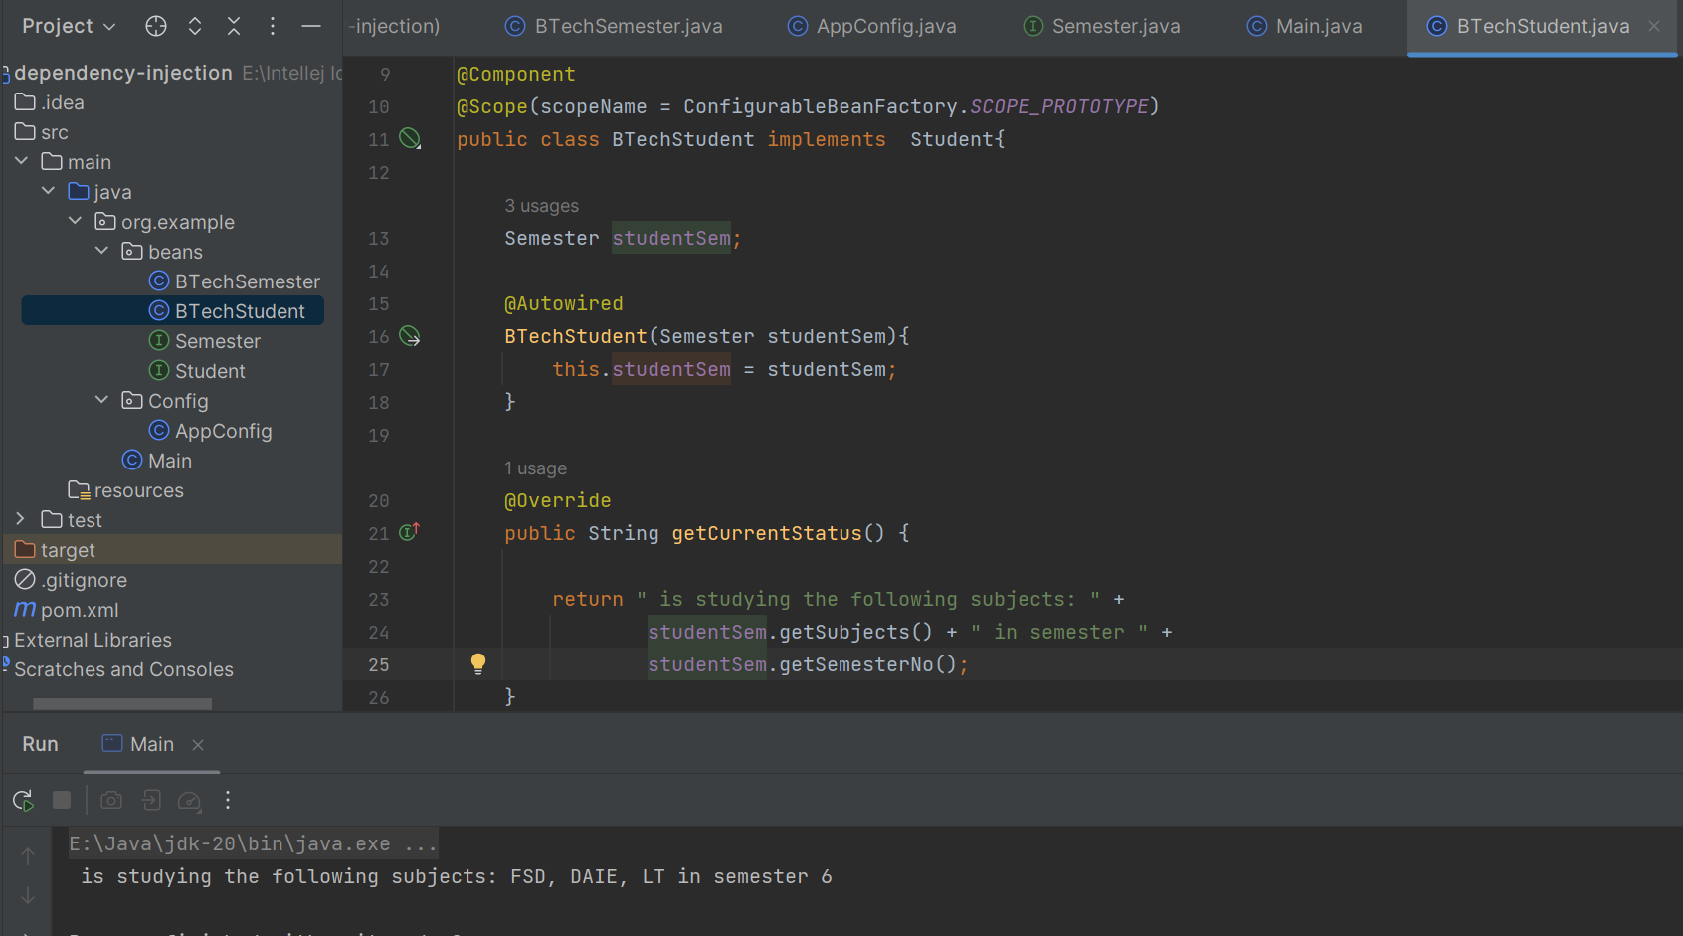

4.AutoWiring using setter

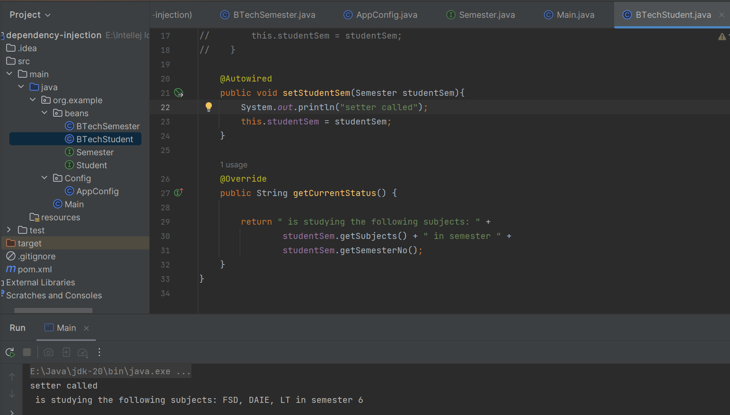

5. using both:

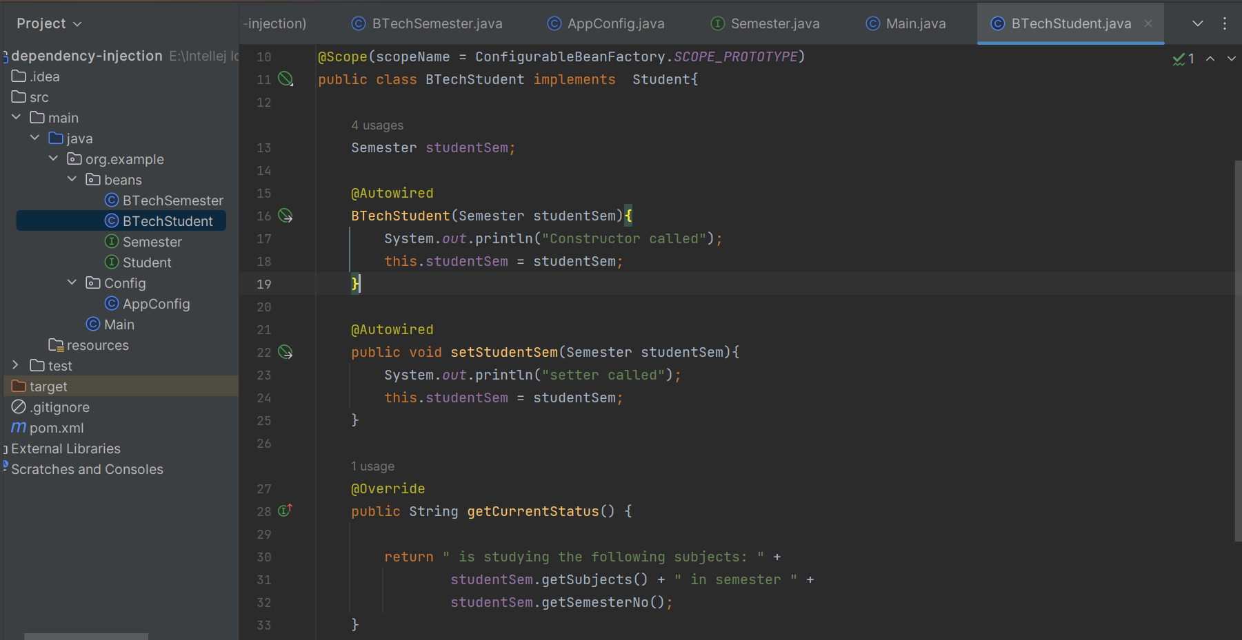

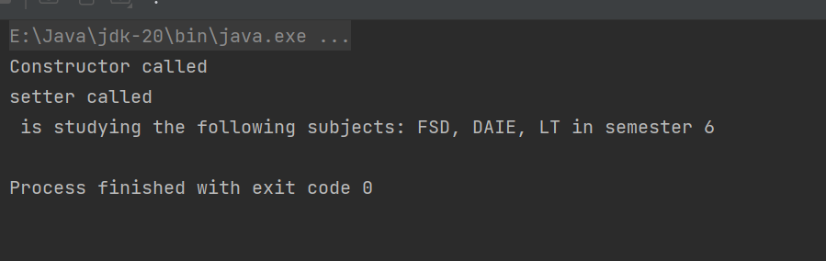

6. when I make MTechSemester implements Semester then autwired gets confused where to go BTech or MTech @Qualifier

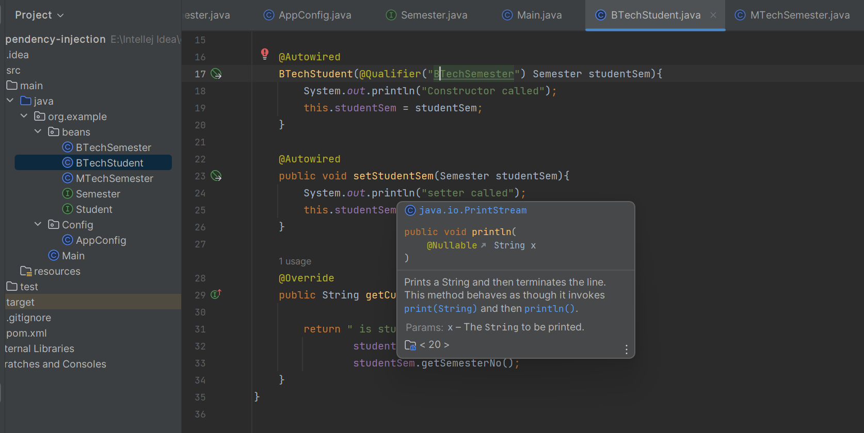

Now calling main both btech and mtech constructor called  
so to remove unnecessary constructor call add lazy  
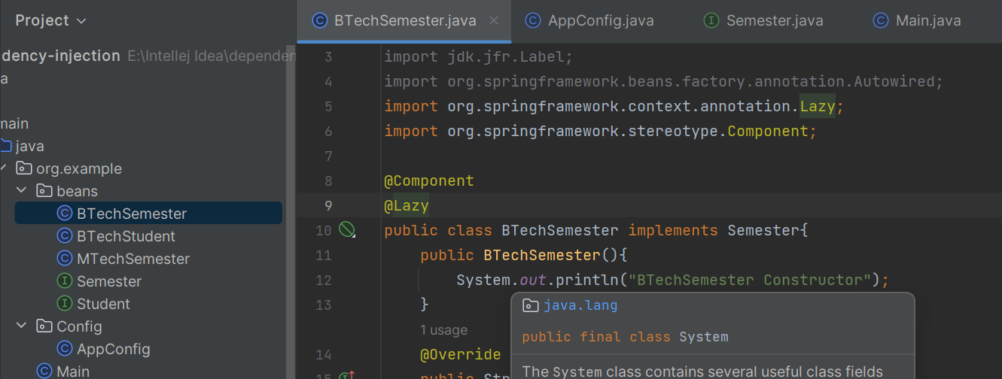

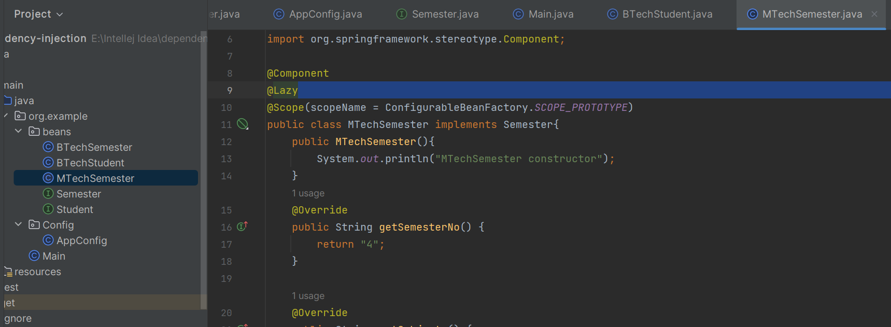

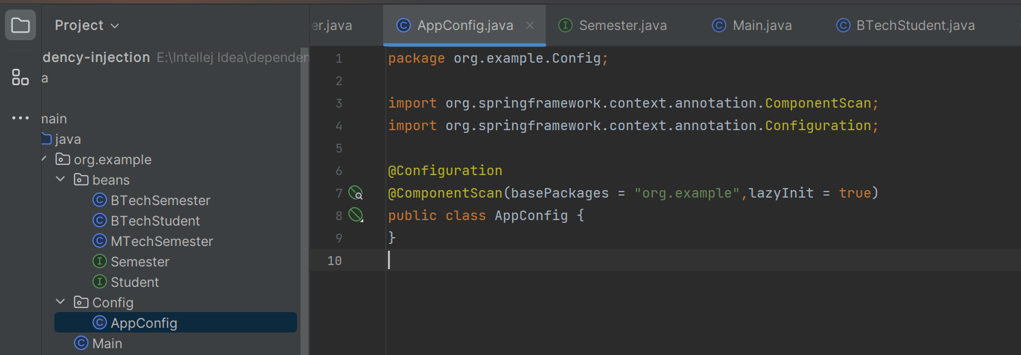

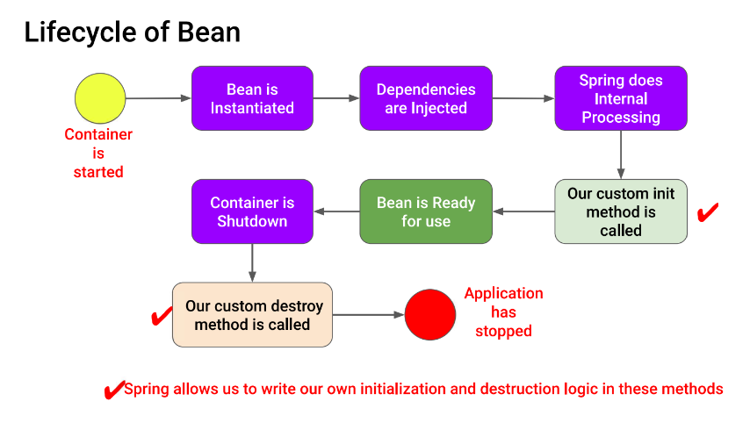

Spring mvc:

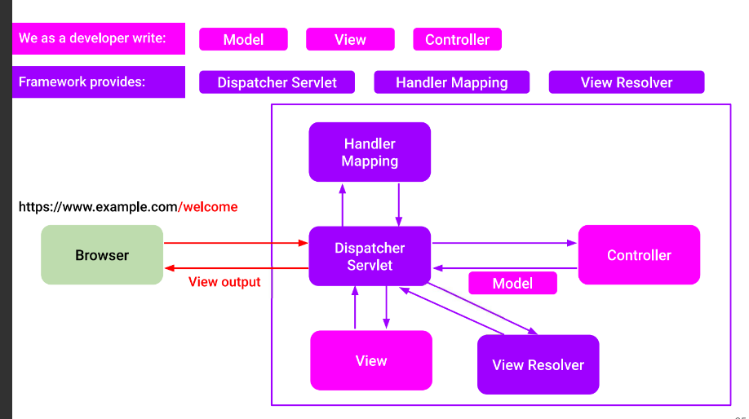

1. Controller with xml file:

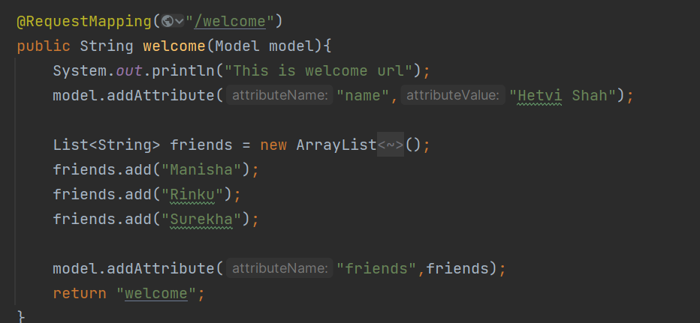

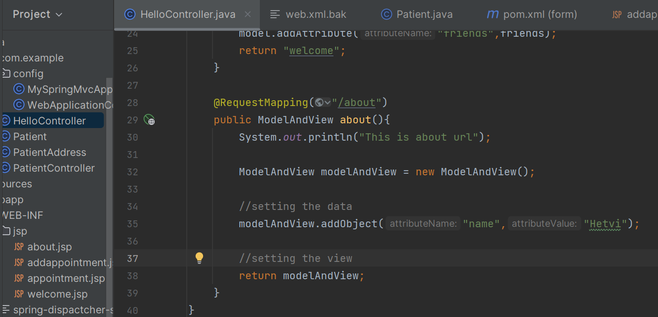

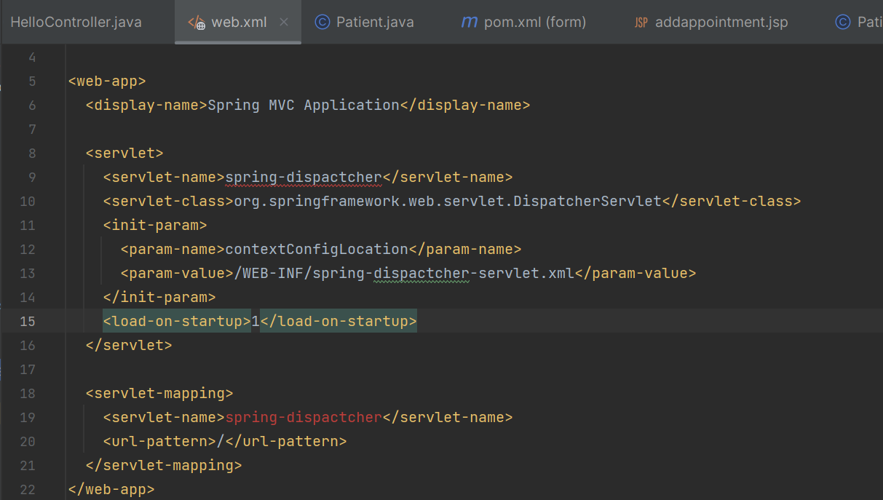

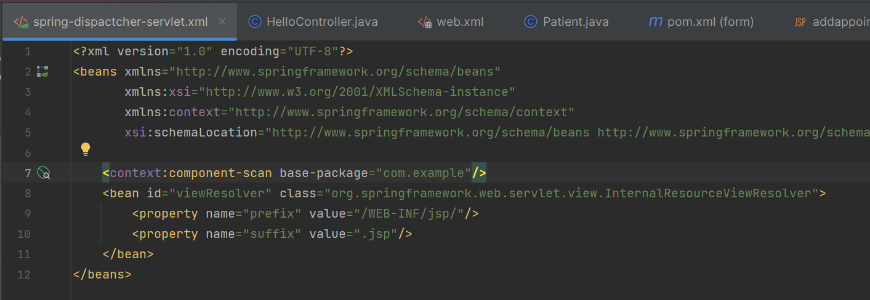

2. without xml file

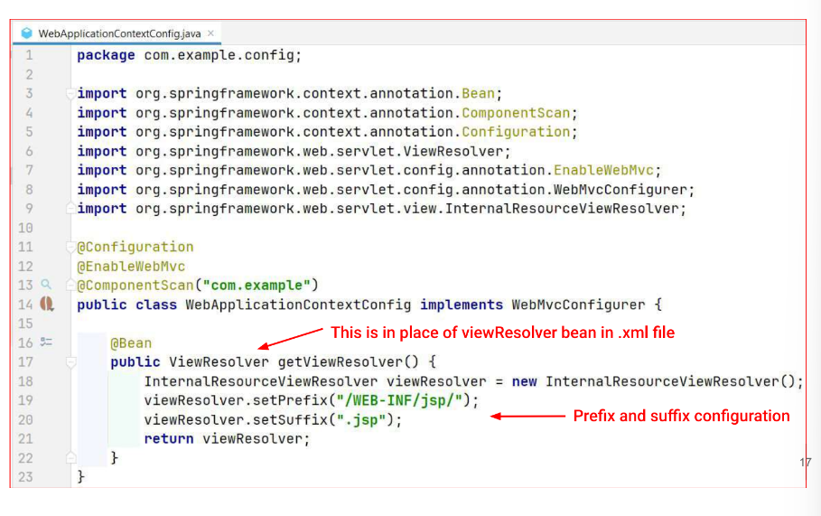

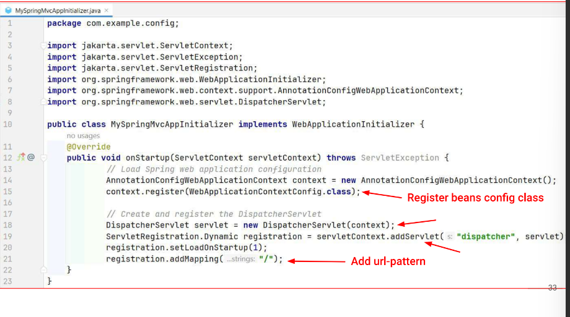

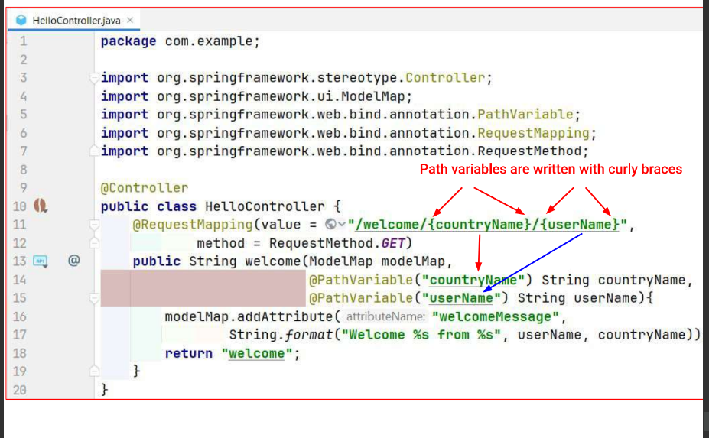

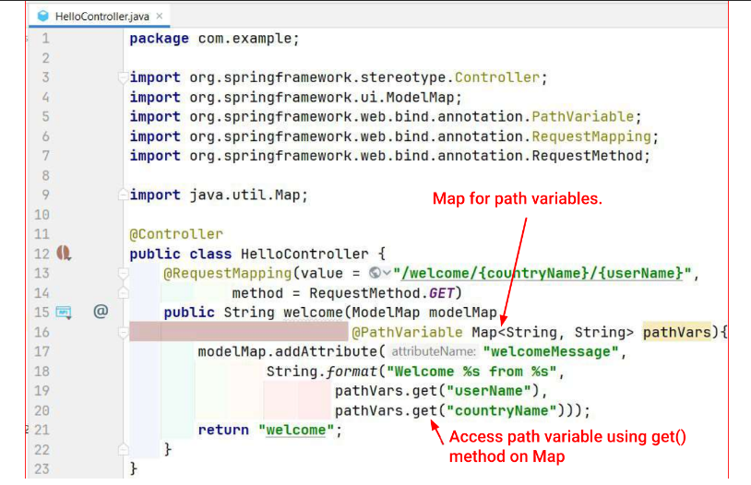

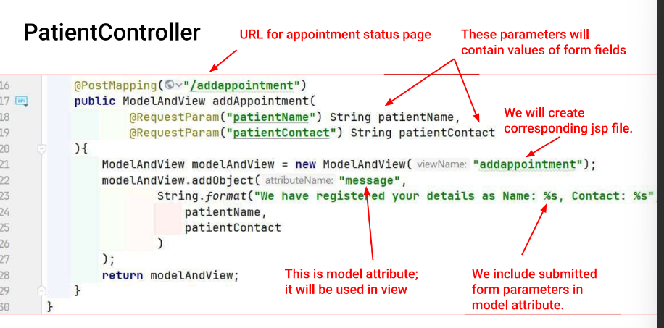

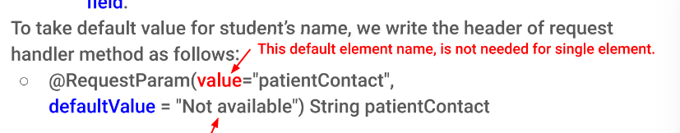

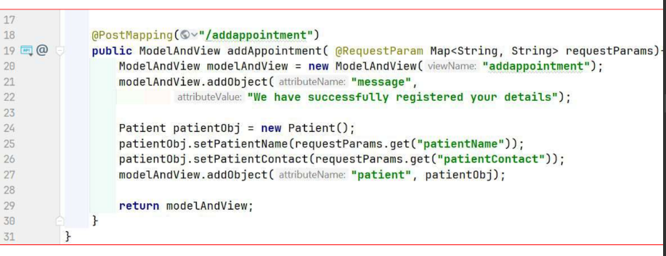

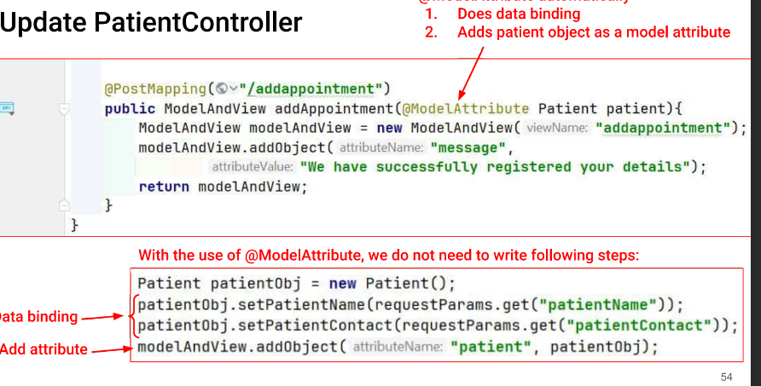

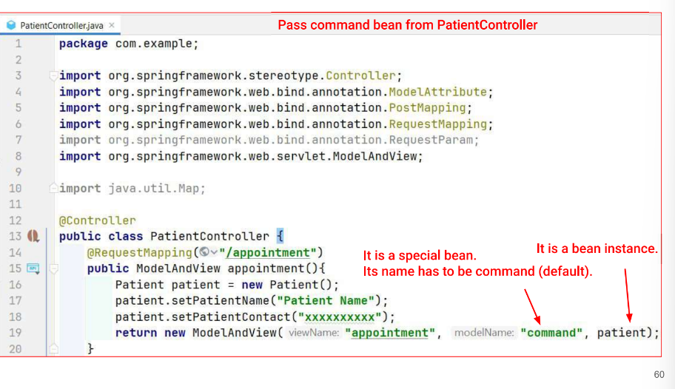

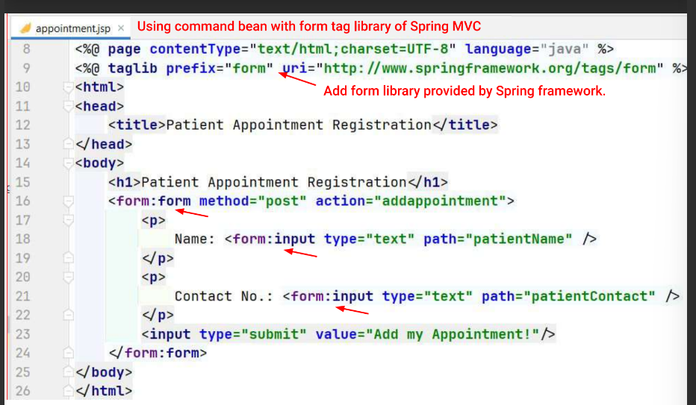

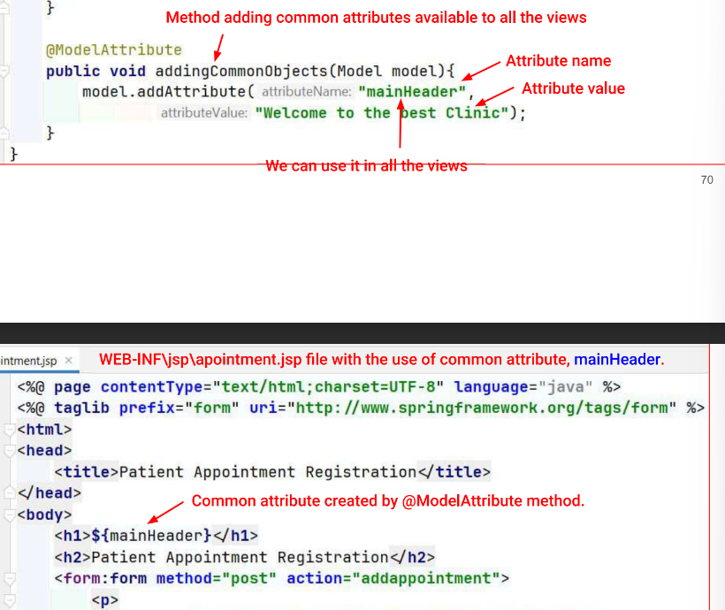

Javascript

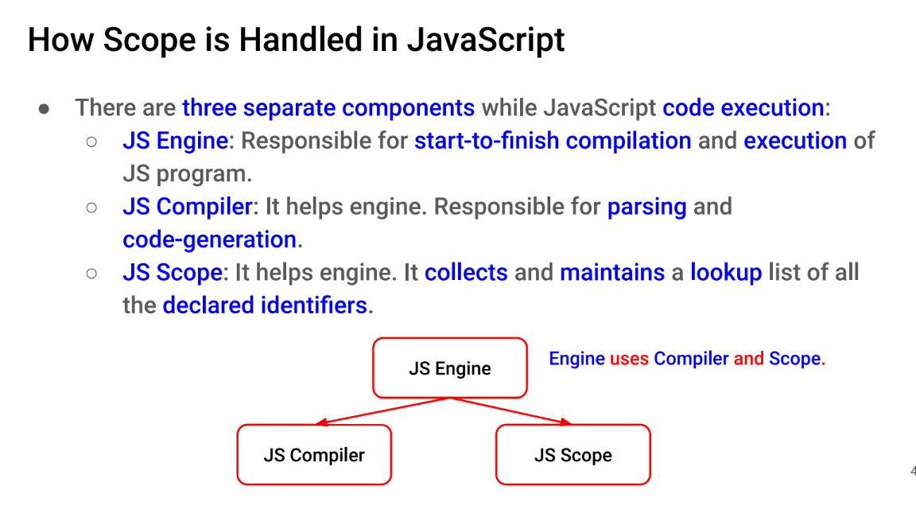

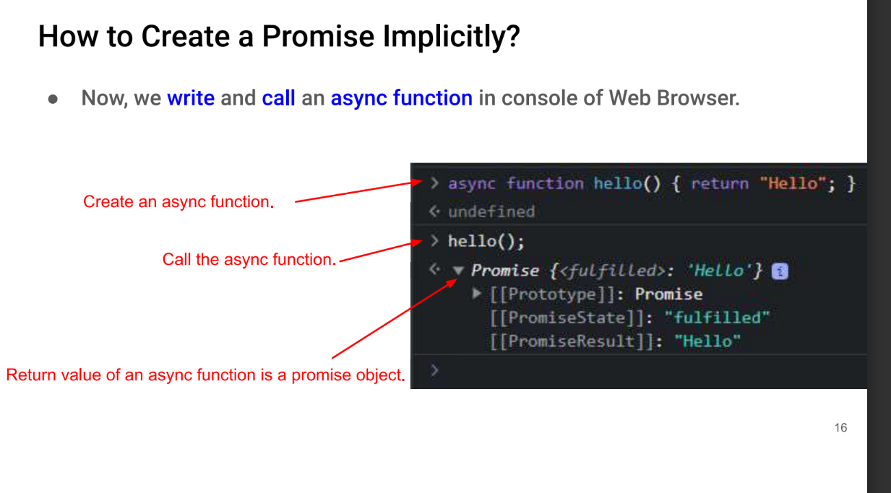

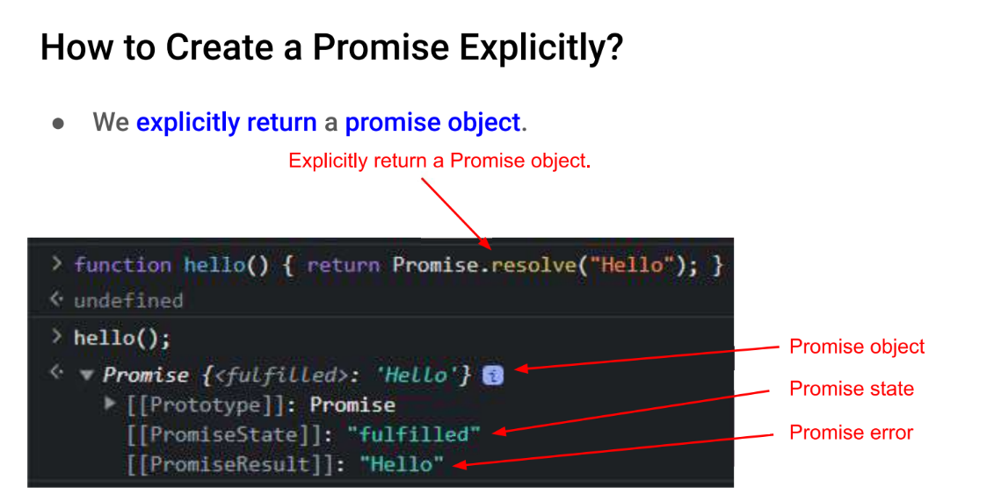

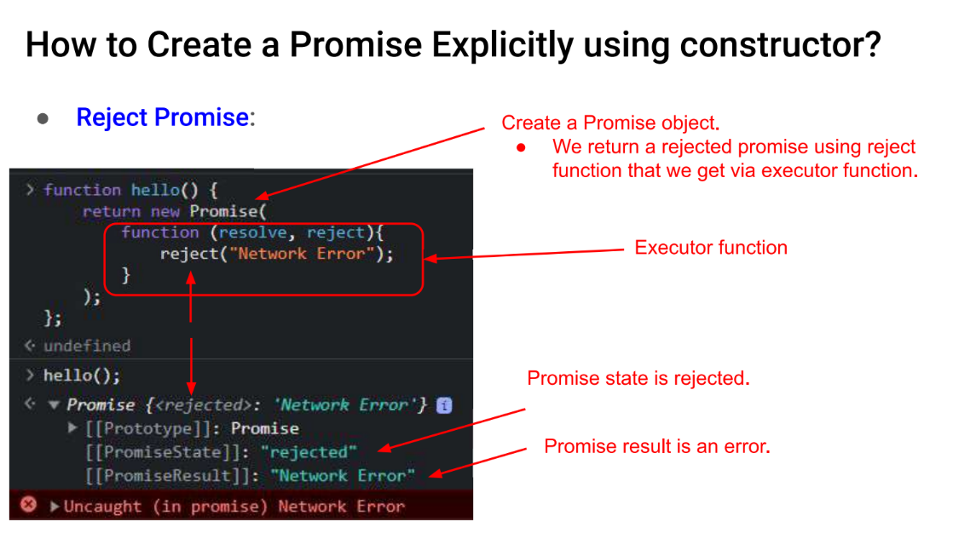

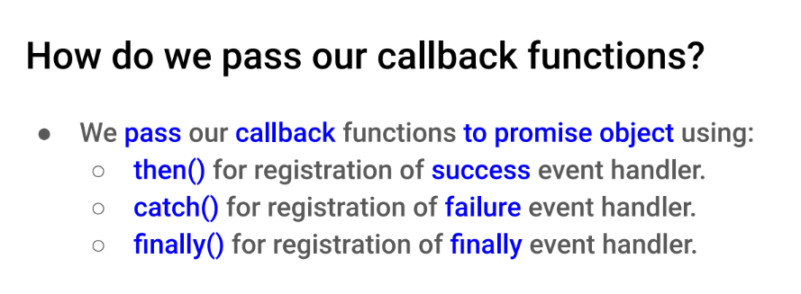

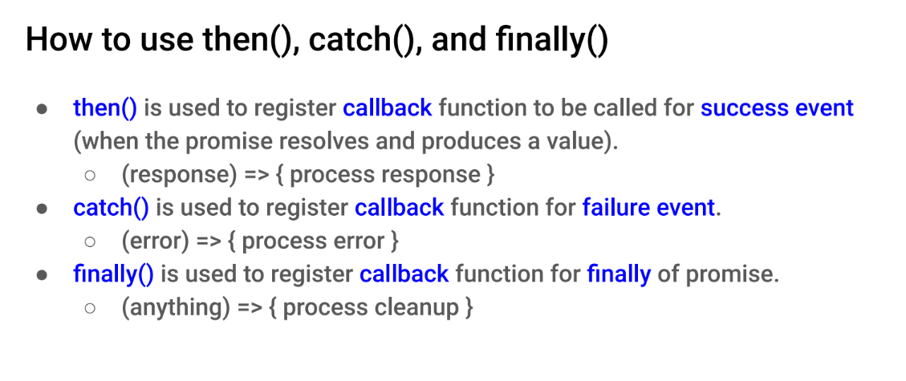

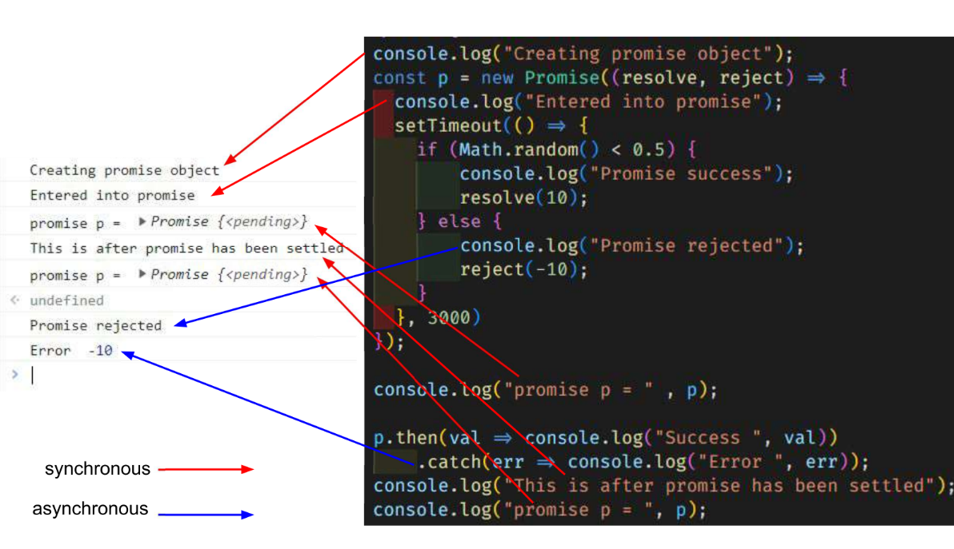

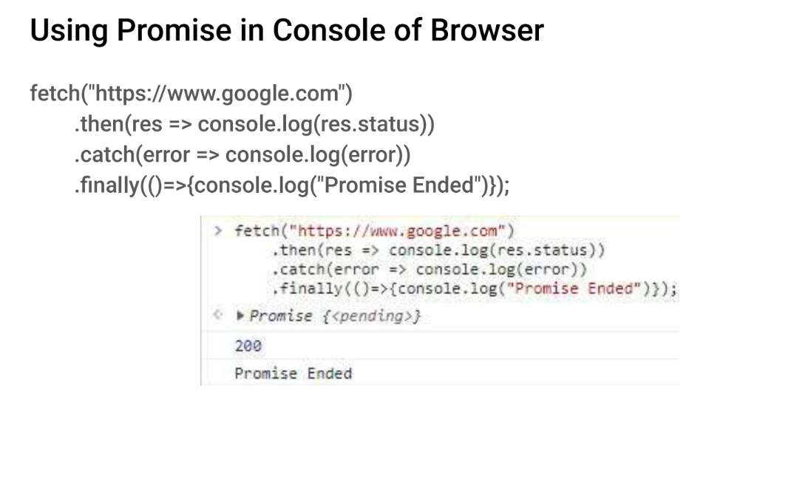

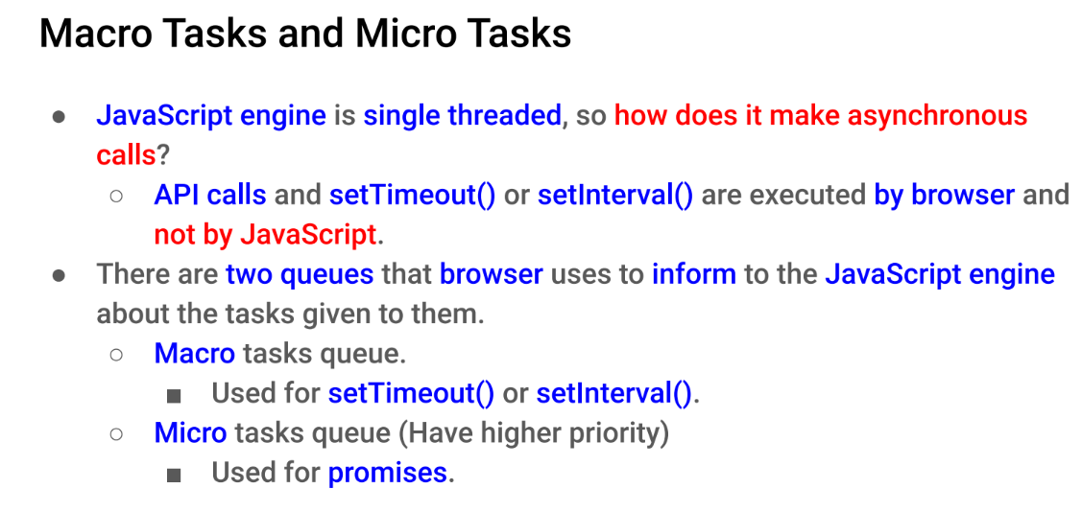

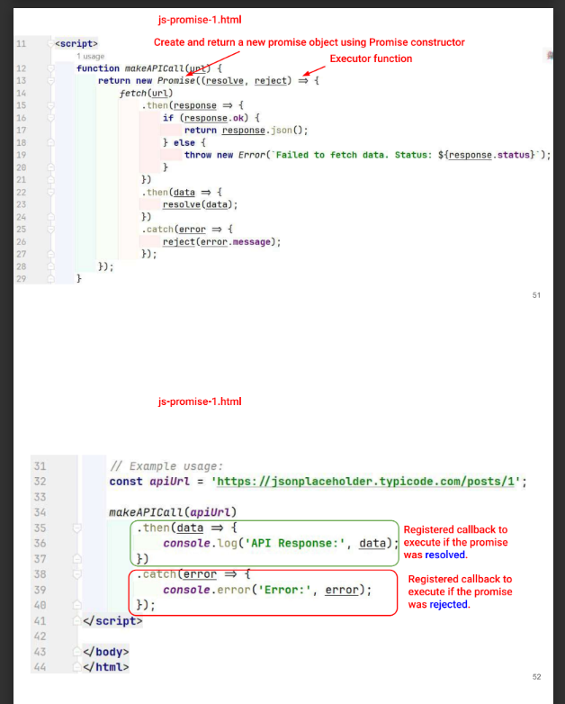

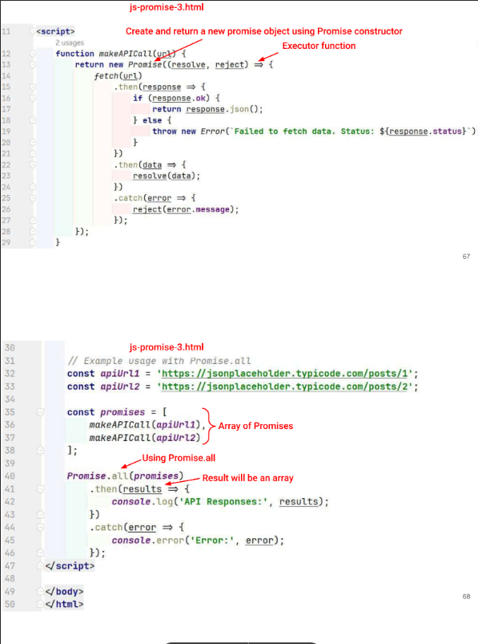

React

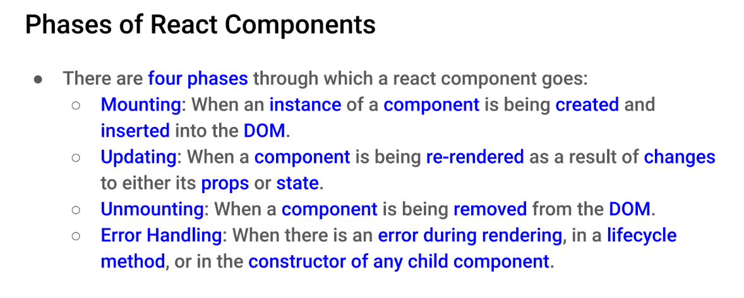

import React, { useState } from "react";

function getInTwoDigits(value){

    if(value < 10){

        value  = "0" + value;

    }

    return value;

}

const getCurrentTime = () => {

    const today = new Date();

    const h = today.getHours();

    const m = today.getMinutes();

    const s = today.getSeconds();

    return `${h}:${getInTwoDigits(m)}:${getInTwoDigits(s)}`;

}

export default function Form() {

  const [answer, setAnswer] = useState("");

  const [error, setError] = useState(null);

  const [status, setStatus] = useState("typing");

  console.log(getCurrentTime(),": ");

  console.log("\tanswer = ",answer);

  console.log("\tstatus = ",status);

  console.log("\terror = ",error);

  if(status === "success"){

    return <h1>That's, right!</h1>;

  }

  const submitForm = (answer) => {

    return new Promise((resolve,reject) => {

        setTimeout(()=>{

            let shouldError = answer.toLowerCase() !== "gandhinagar";

            if(shouldError){

                reject(new Error("God guess but a wrong answer, Try again!"));

            }else{

                resolve();

            }

        },1000);

    });

  }

  const handleSubmit = async (e) => {

    e.preventDefault();

    setStatus("submitting");

    try{

        await submitForm(answer);

        setStatus("success");

    }catch(err){

        setStatus("typing");

        setError(err);

    }

  }

  const handleTextareaChange = (e) => {

    setAnswer(e.target.value);

  }

  return (

    <>

      <h2>Capital of city quiz</h2>

      <p>Which city is the capital of Gujarat?</p>

      <form onSubmit={handleSubmit}>

        <textarea value={answer} onChange={handleTextareaChange} disabled={status === "submitting"} />

        <br/>

        <button disabled={answer.length === 0 || status === "submitting"}>Submit</button>

        {error !== null && <p className="Error">{error.message}</p>}

      </form>

    </>

  );

}

import React, { useState } from "react";

import { sculptureList } from "../Data/Data";

const Gallery = () => {

  const [index, setIndex] = useState(0);

  const [showMore, setShowMore] = useState(false);

  console.log("Gallery: index: " + index);

  const handleClick = () => {

    if (index < sculptureList.length - 1) {

      setIndex(index + 1);

      console.log("handleClick: index: " + index);

    } else {

      setIndex(0);

    }

  };

  let sculpture = sculptureList[index];

*// console.log(sculptureList.length);*

  const handleMoreClick = () => {

    setShowMore(!showMore);

  };

  return (

    <div>

      <button onClick={handleClick}>Next</button>

      <h2>

        <i>{sculpture.name}</i>

      </h2>

      <h3>

        ({index + 1} of {sculptureList.length})

      </h3>

      <button onClick={handleMoreClick}>

        {showMore ? "Hide" : "Show"} details

      </button>

      <div>

        <img src={sculpture.url} alt={sculpture.alt} />

      </div>

      <div>{showMore && <p>{sculpture.description}</p>}</div>

    </div>

  );

};

export default Gallery;